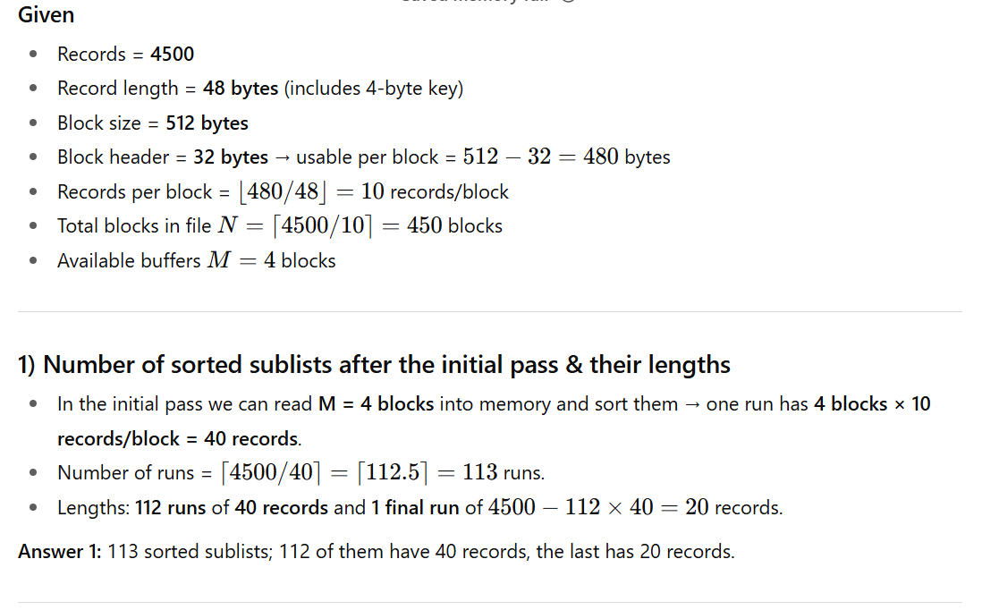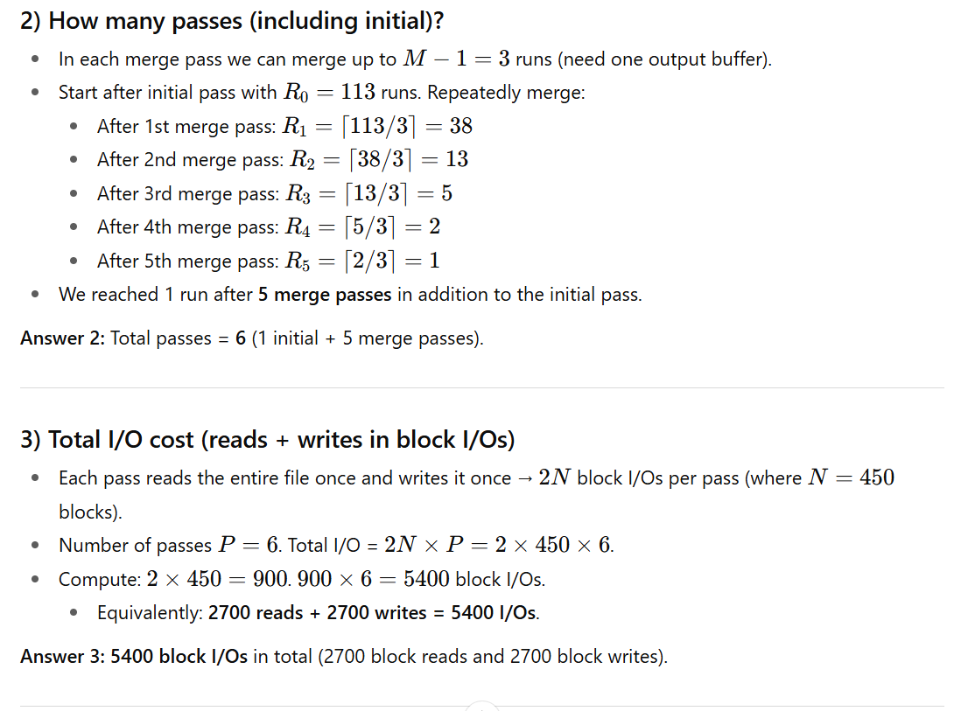
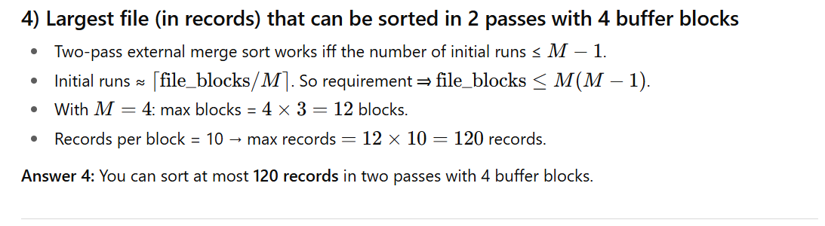

🔹 Merge Sort Concept
Merge Sort is a divide-and-conquer sorting algorithm that works in two main phases:
- Divide (Splitting Phase)
  - The input is divided into smaller sublists until each sublist contains just one element (or is already sorted).
- Conquer (Merging Phase)
  - Sorted sublists are repeatedly merged together into larger sorted lists, until there is only one sorted list left.
👉 Why it’s important in DBMS:
- Databases often deal with files too large to fit in main memory.
- That’s why DBMS uses External Merge Sort — a disk-based variant.
- Process:
  - Read chunks (runs) of data that fit in memory, sort them, and write them back to disk.
  - Then repeatedly merge runs until one sorted file remains.

🔹 Internal Merge Sort (simple case, data fits in memory)

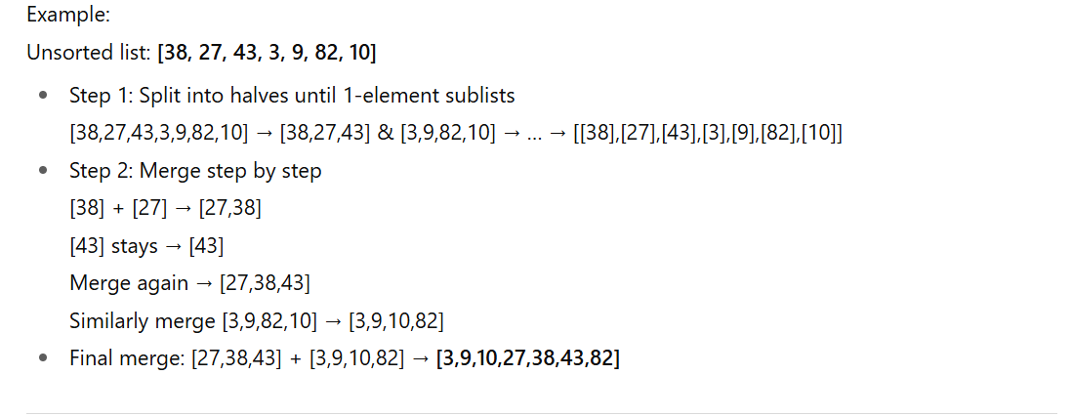
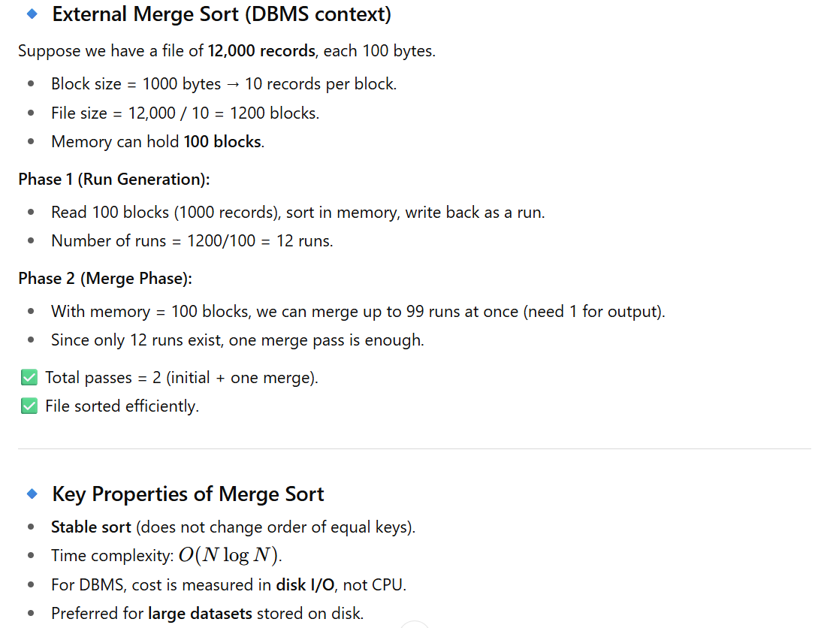
DBMS 4 – Data Representation. Let me teach you the concepts step by step in a clear way with examples.

📘 Concepts in Lecture Notes

1. External Merge Sort
- Used when data doesn’t fit in main memory.
- Process:
  - Read as many blocks as possible into memory, sort them, write as sorted runs to disk.
  - Repeatedly merge runs until one sorted file remains.
- Cost measure: Disk I/Os (reads + writes).
👉 Example:
File = 4500 records, 48 bytes each, 512-byte blocks, 4 buffers.
- Initial pass: produces 113 runs.
- Total passes: 6.
- Total I/O = 5400.
- With 4 buffers, max 120 records can be sorted in 2 passes.

2. Data Representation
DBMS needs to store fields → records → blocks → files.
- Field: one attribute value (e.g., EmpName = “Ali”).
- Record: collection of fields (tuple).
- Block: unit of disk I/O (fixed size, e.g., 4KB). Holds one or more records.
- File: collection of blocks belonging to the same relation.
👉 Storing blocks from the same file together reduces disk seek time.

3. Record Schema
- Defines: number of fields, type of each field, order of fields.
- DBMS uses schema to know where attributes are inside a record.

4. Fixed-Length vs. Variable-Length Records
- Fixed length:
  - Every field has a fixed size.
  - Easier to store, but may waste space due to padding (alignment to 4 or 8 bytes).
- Variable length:
  - Fields like strings, repeating attributes, or unknown formats.
  - Need a record header with offsets or pointers to fields.
👉 Example:
- Fixed: EmployeeID (4 bytes), Age (2 bytes), Salary (8 bytes).
- Variable: EmployeeName (up to 50 chars), Comments (arbitrary text).

5. Record Header
Stored at the beginning of a record. May contain:
- Pointer to schema.
- Record length.
- Timestamps (last modified).
- Pointers to fields.

6. Block Header
Stored at beginning of each block. May contain:
- Offset table (where each record begins).
- Links to other blocks in the file.
- Relation ID, timestamp, free space info.

7. Unspanned vs. Spanned Records
- Unspanned:
  - A record must fit entirely in one block.
  - Wastes space (up to 50%).
- Spanned:
  - Records can cross block boundaries.
  - Needs extra headers to mark fragments (first, middle, last, etc.).
- Forced spanning: if record > block size → must span across multiple blocks.
👉 Example:
- Record = 52 bytes, Block = 500 usable bytes.
  - Unspanned: only 9 records per block → 500 blocks for 4500 records.
  - Spanned: can use leftover space → only 486 blocks.

8. Sequencing
- Records in a file can be ordered by a key.
- Sequential file: records stored physically in order.
- If space runs out, new records may be stored elsewhere with pointers (like linked list).
👉 Used for operations like merge join.

9. Field Alignment
- Some systems require fields to start at multiples of 4 or 8 bytes for performance.
- Leads to padding waste.
👉 Example:
Fields = [15-char string (15 bytes), int (2 bytes), date (10 bytes), time (8 bytes)].
- No alignment: 35 bytes.
- 4-byte alignment: 40 bytes.
- 8-byte alignment: 48 bytes.

🔑 Summary
Your lecture covers two big parts:
- Sorting (Merge Sort in DBMS): how large files are sorted externally, with exercises on runs, passes, and I/O cost.
- Data Representation: how fields → records → blocks → files are organized, including fixed/variable records, headers, spanning/unspanned records, and sequencing.

📘 DBMS Data Representation & Merge Sort – Cheat Sheet

🔹 External Merge Sort
- When used: File too large for main memory.
- Process:
  - Initial Pass: Load M blocks into memory, sort, write as runs.
  - Merge Passes: Merge up to (M-1) runs at once.
- Cost: Each pass = 2 × file size (in blocks) I/Os.
- Passes needed:
\text{#passes} = 1 + \lceil \log_{M-1} (\#runs) \rceil
👉 Example:
File = 4500 recs, 48B each, block=512B (480 usable → 10 rec/block).
- Blocks = 450. Buffers = 4.
- Initial runs = 113.
- Passes = 6.
- I/O = 5400.
- Max file in 2 passes = M(M−1)×rec/block.

🔹 Data Representation
Field → Record → Block → File
- Field: one attribute (e.g., EmpName).
- Record (tuple): collection of fields.
- Block: disk I/O unit (e.g., 4 KB) containing records.
- File (relation): collection of blocks for same schema.

🔹 Record Schema
- Info about: number of fields, type, order.
- Needed to locate fields in records.

🔹 Fixed vs. Variable-Length Records
Type | Features | Pros | Cons
Fixed | Fields fixed size | Simple access | Wastes space (padding)
Variable | Fields differ in size (e.g., strings) | Saves space | Needs header with offsets

🔹 Record Header
Contains metadata like:
- Pointer to schema.
- Record length.
- Timestamp (last modified).
- Pointers to fields.

🔹 Block Header
Contains:
- Offset table (locations of records).
- Links to other blocks.
- Relation ID.
- Free space info.

🔹 Spanned vs. Unspanned Records
Type | Definition | Pros | Cons
Unspanned | Record must fit in one block | Simpler | Wastes space (~50%)
Spanned | Records may cross block boundaries | Better utilization | Extra headers needed
Forced span | Record > block size → must span multiple blocks | Handles large recs | Overhead

🔹 Sequencing (File Ordering)
- Records ordered by key.
- Types:
  - Physical order (records stored sequentially).
  - Linked order (each record has pointer to next).
- Used for efficient scanning/merge join.

🔹 Field Alignment
- Fields may need to start at multiples of 4 or 8 bytes.
- Causes padding waste.
👉 Example: [15-char string (15B), int (2B), date (10B), time (8B)]
- No alignment: 35B
- 4-byte alignment: 40B
- 8-byte alignment: 48B

✅ Key Takeaways
- DBMS uses external merge sort for huge files.
- Records stored in blocks with headers for metadata.
- Fixed/variable records trade simplicity vs. flexibility.
- Spanned/unspanned trade simplicity vs. space efficiency.
- Sequencing improves ordered access.
- Alignment affects space usage.

